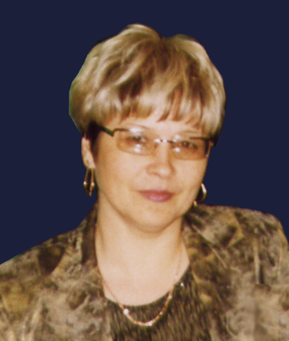
Rotanova Irina N. – Ph.D., Head of Ecological and Geographical Mapping Laboratory of Institute for Water and Environmental Problems SB RAS
Research and Professional Experience: ecological cartography.
Member of the committee on theoretical cartography of the International Cartography Association.
Scientific Secretary of Altai Regional Division of the Russian Geographical Society

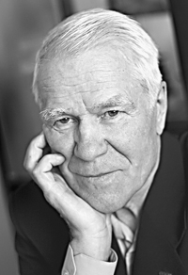
Revjakin Viktor S. – Dr. Sc (Geography), Prof., Head of Landscape Planning Department of Altai State University, Dr,
Research and Professional Experience: geography and ecological cartography.

THE COMPLEX ATLAS OF BARNAUL СITY
V.S. Revjakin, I.N. Rotanova*
Altai State University,
*Institute for Water and Environmental Problems SB RAS
rotanova@iwep.asu.ru

Urban territories as the most transformed natural areas characterized by as geographic as evident social-economic features have most prerequisites for a complex cartographic analysis. The national experience in creation of urban territory atlases allows us to systemize and objectively represent the diverse information on nature, industrial potential, social-economic conditions, the urban environment quality and its comfortness. The complex reference-scientific atlas of Barnaul city was created as a traditional one and, as in the form of a computer-based cartographic-information system. This atlas includes more than 60 thematic maps, original by content. By structure, the atlas has several sections, i.e. introduction, historic background, territory natural conditions and resources, social-economic aspects and habitat quality. Scales of 1:100 000, 1:75 000 were used for mapping the city territory, while 1:10 000, 1:25 000 – for its administrative districts. While mapping, the non-uniformly scaled approach makes possible to combine visibility with detail representation of a natural-industrial situation. It should be noted that the development of the unified geographical and mathematical base for all maps has a particular importance especially for methodic aspect of maps construction. The choice of map arrangement is determined by the vicinities coverage and the accounting of forward town planning. Depending on thematic content some variations are probable when the unitized elements of general geographic content are prevailed; as this takes place, some objects represented on the topographic map are transformed into the ones of special content.
The Introduction contains general information on Barnaul, a physical-geographical map of the city and its surroundings, a fragment of space image with elements of digital relief pattern.
The Historic section of the atlas includes the archival maps fragments starting from “The drawing book of Siberia” by S. U. Remezov dated to 1701. Here, one can find the fragments of major maps constructed in the18th century where Barnaul position and first plans of the town since 1837 are specified (Fig. 1).
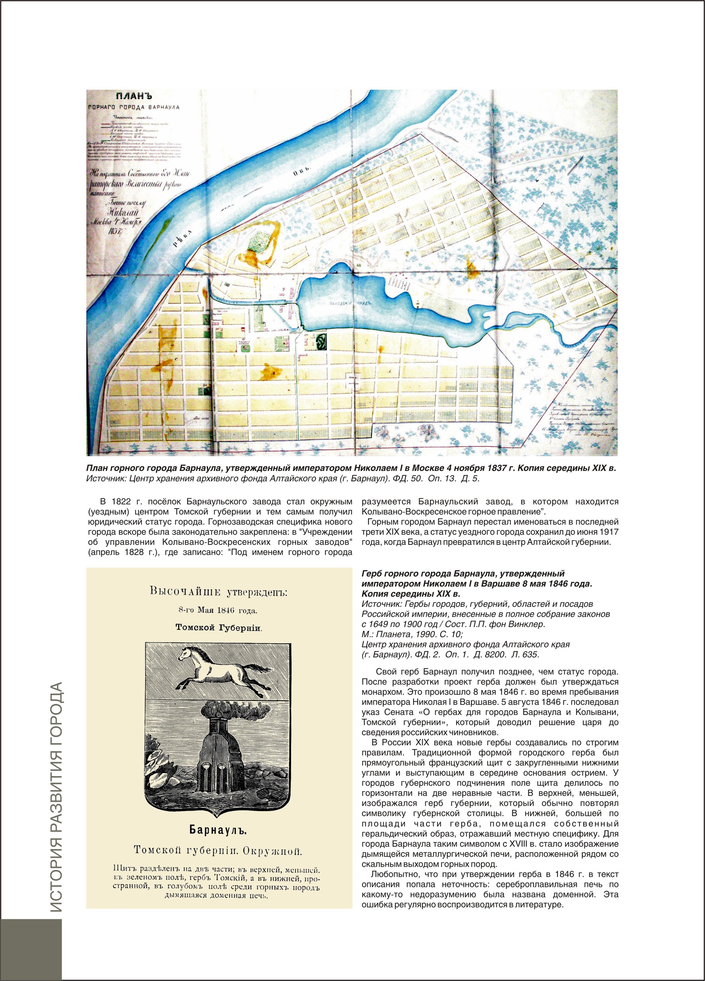

Fig. 1. First plans of the Barnaul, 1837
The atlas reconstructs step-by-step expansion of the town building up in 18-20 centuries. The historic section gives a clear idea on the principal stages of town development and its formation as one of industrial centers of Siberia since the 18th century. Some fragments of hand-made historical maps are published for the first time.
Section “Natural conditions and resources” demonstrates the main physical-geographical characteristics of the territory occupied by Barnaul; climate, relief, geological structure, engineering and hydrogeological conditions, soils, vegetation, wild world and the main natural processes, e.g. channel and landslide ones. This section ends with the natural landscapes map that depicts the reconstructed natural complexes as a background where later on the modern town was built (Fig. 2).
Current urban landscapes differ greatly from the natural ones. They can be split in 4 categories: natural with elements of regulation, anthropogenic- natural, architectural-residential and industrial ones. The social-economic section includes a series of present-day landscapes maps on industry, power engineering, demography, transport, communication, municipal economy, public health, trade, etc. The maps are provided with graphs, tables, diagrams. Territorial and demographic dynamics is presented as well.
A separate section is devoted to administrative districts of the city. Here, the key industrial and social-cultural objects, road net, residential areas are shown. (Fig. 3).
At the end one can find the City Development Plan.
Special emphasis is put on ”Habitat quality” section that contains maps of Barnaul housing resources, level of improvement, pollution of the atmosphere and surface waters, medical-ecological conditions, sanitary-hygienic state. Besides, this section gives zoning made with the use of a set of unfavorable ecological factors. Barnaul is presented as an integral city designing and building infrastructure. Industrial impact on population health can’t be evaluated without a complex cartographic analysis of the situation, especially urban pollution.
Construction of a series of analytical and integral maps that represent the key features of industrial environment of the city allows us to reveal specific and most unfavorable situations, regularities of their distribution within the territory. Complex evaluation maps show territorial difference in urban quality and state as a whole. The complexity of such maps construction lies in the forced accounting of huge number of parameters that 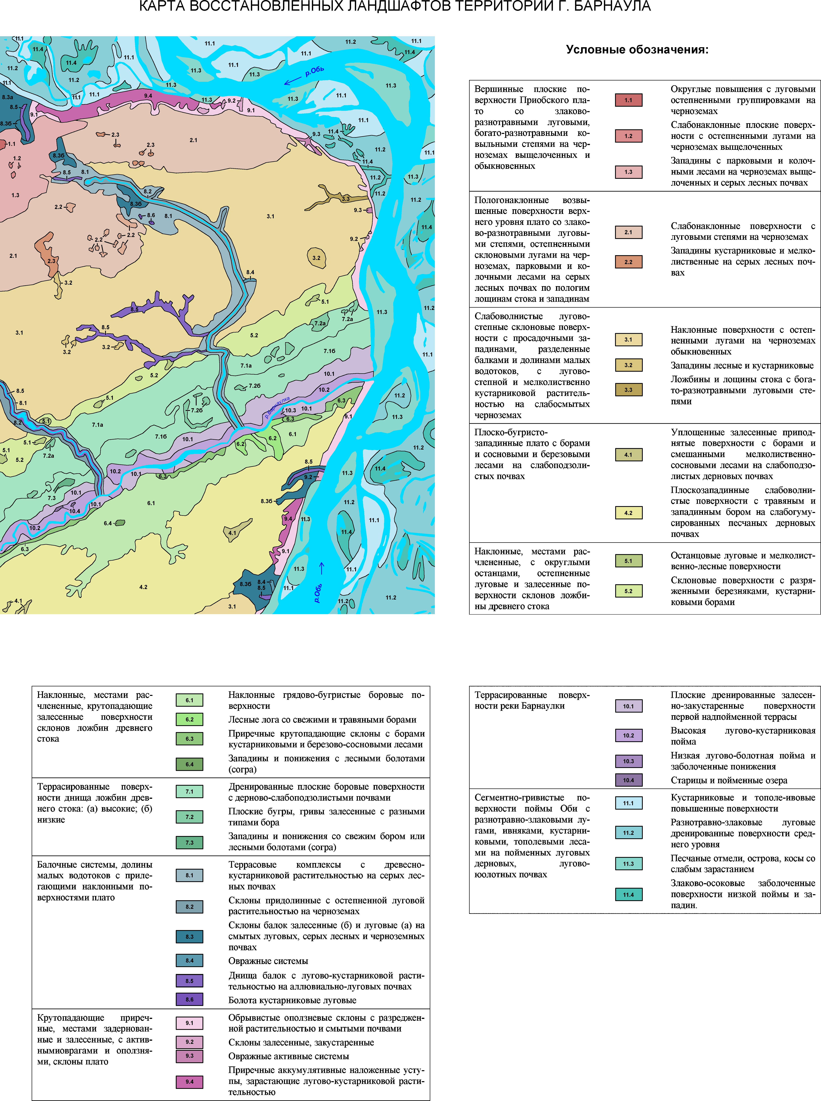

Fig. 2. Map “The natural landscapes of Barnaul sity”

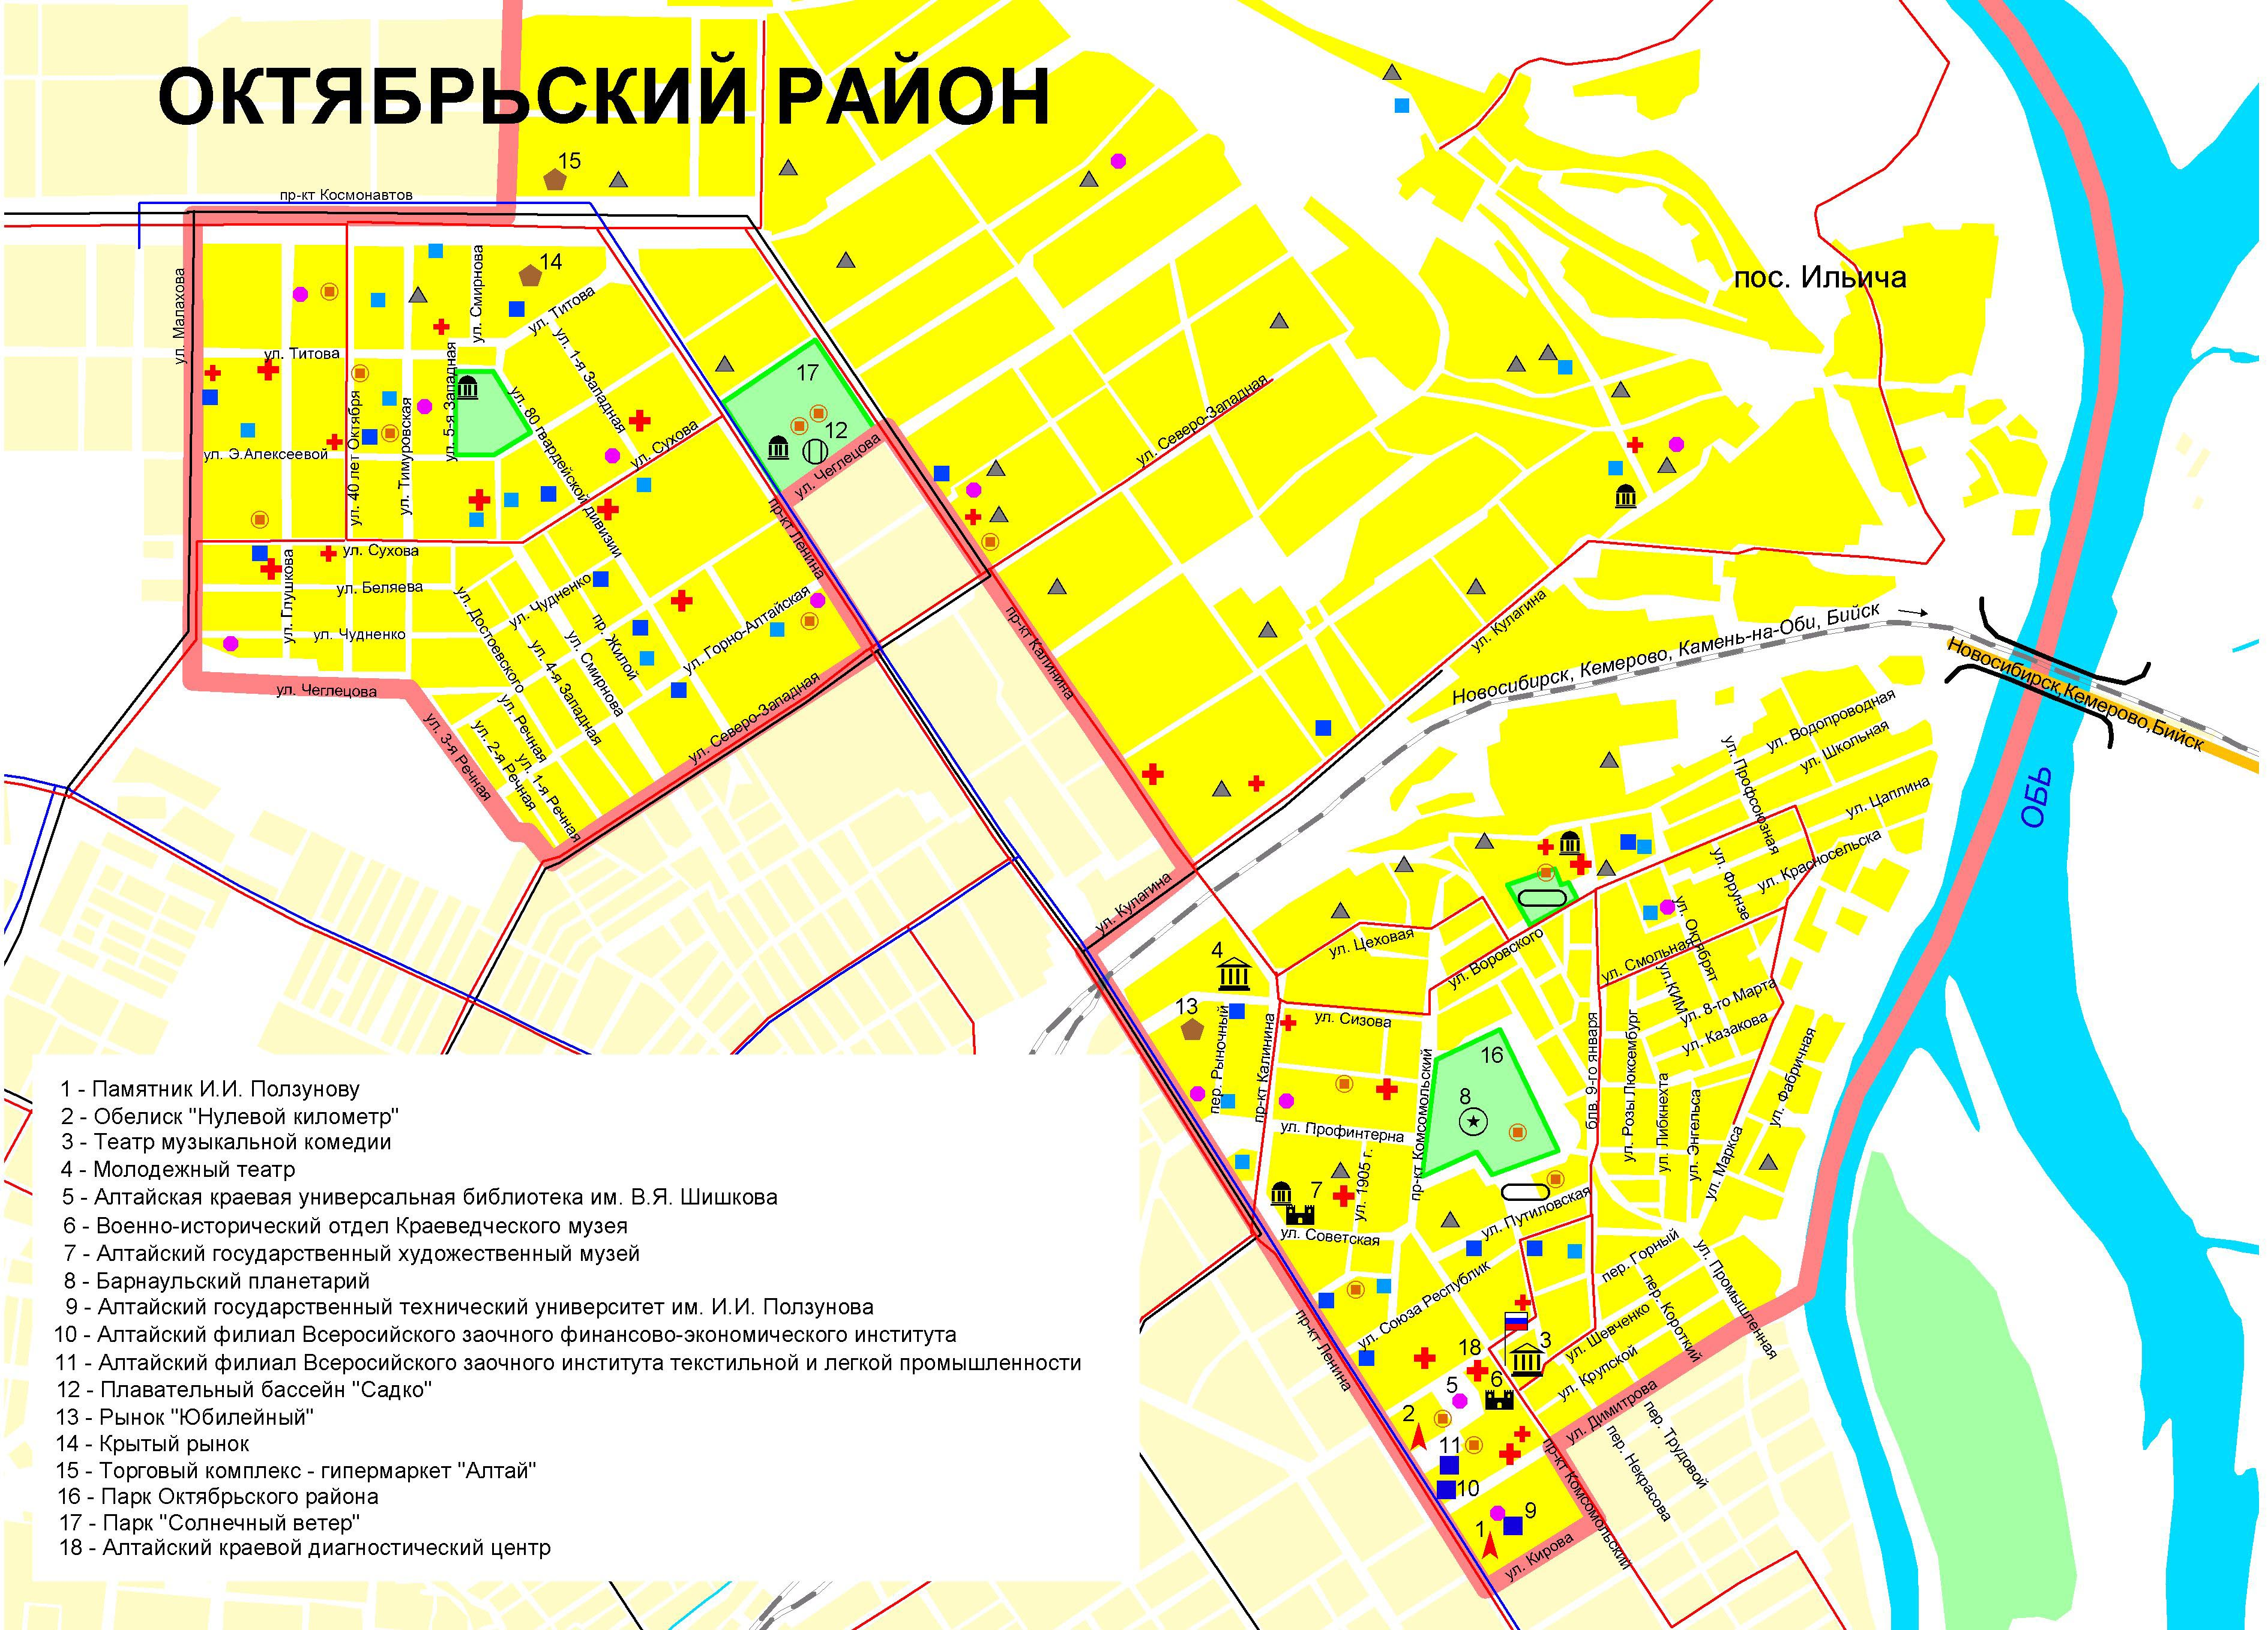

Fig.3. Map “ Oktjabrski administrative districts of the Barnaul”

characterize urban quality with the followed territory zoning based on a combination of unfavorable ecological factors (Fig. 4).
When creating the atlas, geoinformation mapping technologies were used to represent relations and dynamics of natural, natural-industrial and social-economic areas of the urban environment, and to apply uniform principles, uniform topographical and thematic bases in map construction.
The concept, the subject, thematic content, approaches and methods of map construction presented in Atlas of Barnaul are considered to be original. In the course of map creation the present-day requirements to complex cartographic maps were met.
The atlas is of practical importance because it is distinguished by high cognitive level and makes possible to improve efficiency of information decision support for urban territory management.

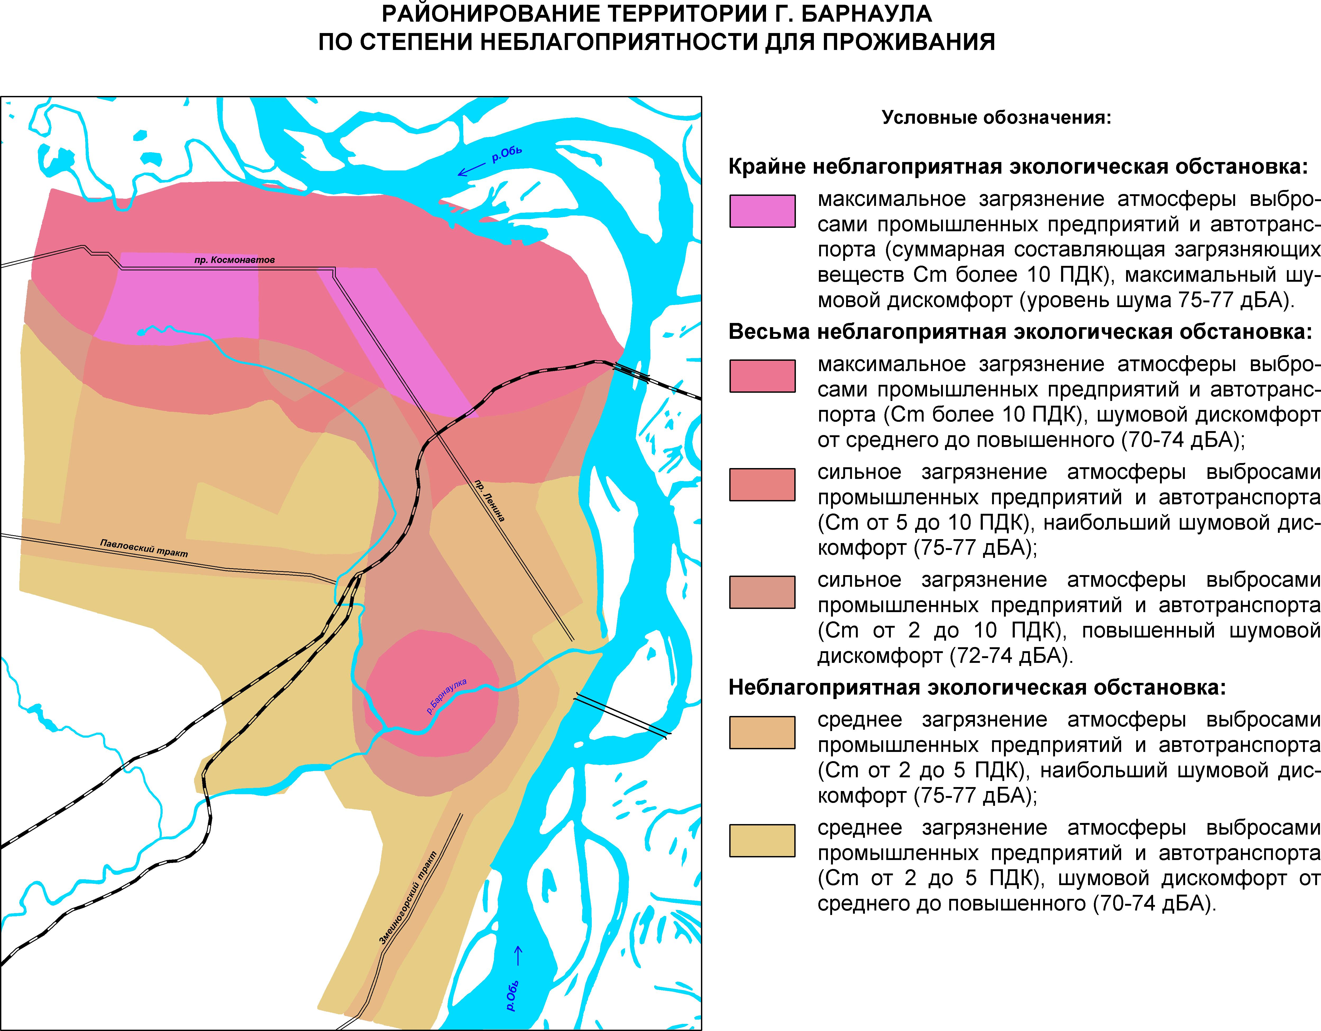

Fig. 4. Map “Combination of unfavorable ecological factors”

